

|  |  |  |  |  |  |  |  |  |
| --- | --- | --- | --- | --- | --- | --- | --- | --- |
|  | | | | | | | | |
|  | | COMPILER DESIGN LAB | | | | |  | |
|  |  | | | | | | |  |
|  | | | |  |  | | | |
|  | | | | SUBMITTED BY: |  | | | |
|  | | | | SAMAR MITTALMIS: 112315159FACULTY:DR MAYANK LOVANSHI |  | | | |
|  | | |  | | |  | | |

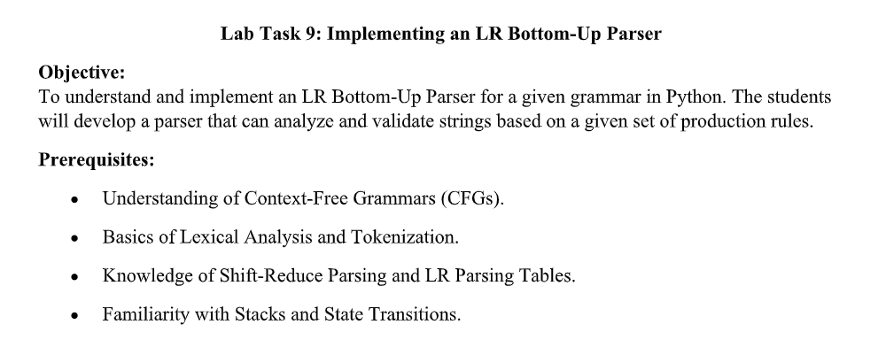

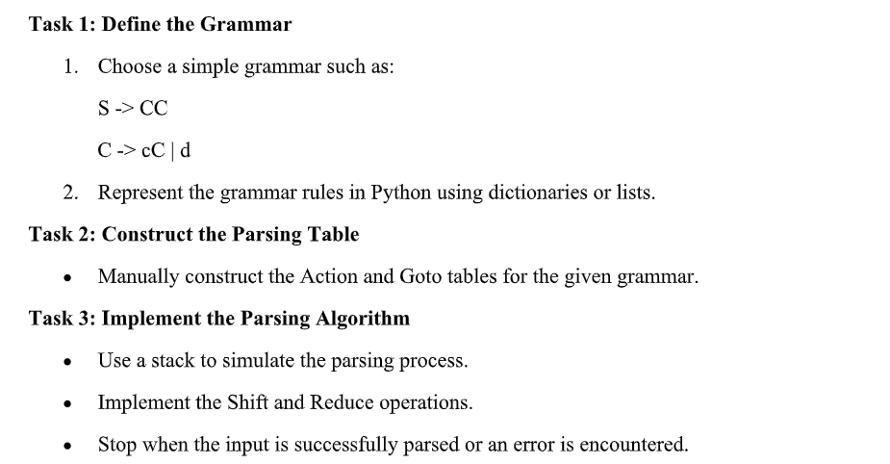

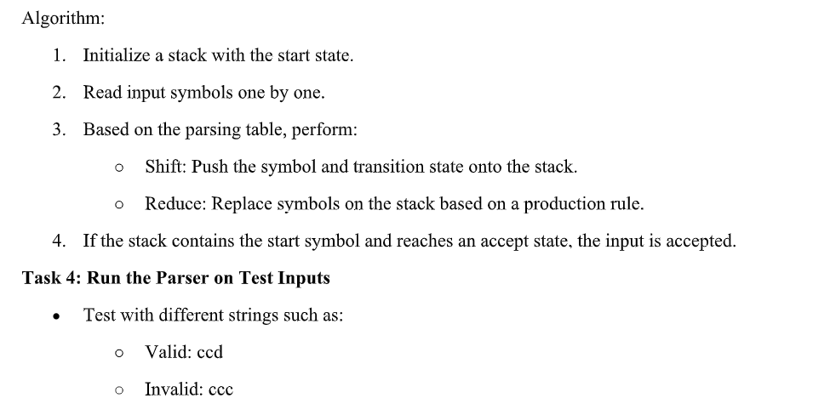

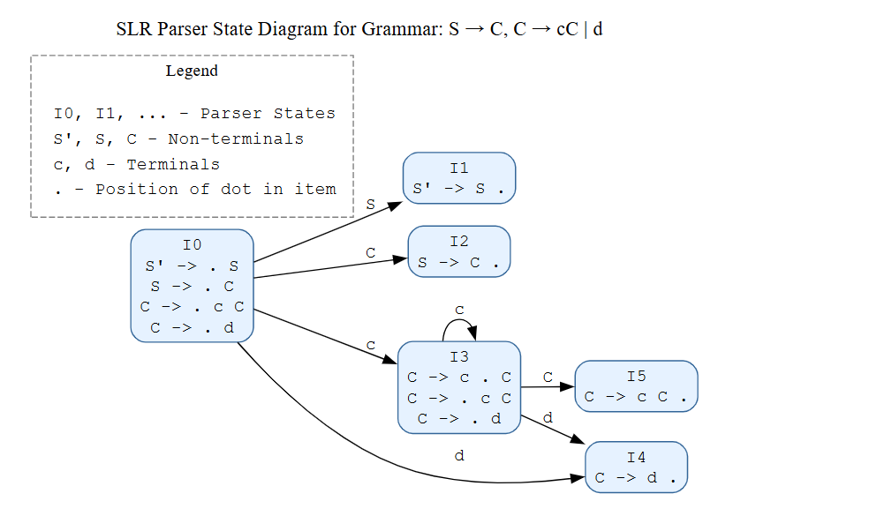

## PYTHON CODE :

import copy

from collections import defaultdict

class SLRParser:

    def __init__(self, grammar_rules, non_terminals, terminals, start_symbol):

        self.rules = grammar_rules

        self.non_terminals = non_terminals

        self.terminals = terminals

        self.start_symbol = start_symbol

        self.augmented_rules = []

        self.states_dict = {}

        self.state_map = {}

        self.state_count = 0

        self.diction = defaultdict(list)

        self.firsts_cache = {}

        self.follows_cache = {}

        self.parse_table = None

        self.numbered_rules = {}

    def parse(self):

        print("\nOriginal grammar input:\n")

        for rule in self.rules:

            print(rule)

        print("\nGrammar after Augmentation: \n")

        self.augmented_rules = self.augment_grammar()

        self.print_result(self.augmented_rules)

        self.start_symbol = self.augmented_rules[0][0]

        print("\nCalculated closure: I0\n")

        I0 = self.find_closure([], self.start_symbol)

        self.print_result(I0)

        self.states_dict[0] = I0

        self.generate_states()

        print("\nStates Generated: \n")

        for st in self.states_dict:

            print(f"State = I{st}")

            self.print_result(self.states_dict[st])

            print()

        self.create_parse_table()

    def augment_grammar(self):

        new_rules = []

        new_start = f"{self.start_symbol}'"

        while new_start in self.non_terminals:

            new_start += "'"

        new_rules.append([new_start, ['.', self.start_symbol]])

        for rule in self.rules:

            lhs, rhs = [x.strip() for x in rule.split("->")]

            for subrule in rhs.split('|'):

                rhs_items = subrule.strip().split()

                # Add dot at beginning

                rhs_items.insert(0, '.')

                new_rules.append([lhs, rhs_items])

        return new_rules

    def find_closure(self, input_state, dot_symbol):

        if dot_symbol == self.start_symbol:

            closure_set = [rule for rule in self.augmented_rules if rule[0] == dot_symbol]

        else:

            closure_set = input_state

        prev_len = -1

        while prev_len != len(closure_set):

            prev_len = len(closure_set)

            temp_closure = []

            for rule in closure_set:

                dot_index = rule[1].index('.')

                if rule[1][-1] != '.':

                    next_symbol = rule[1][dot_index + 1]

                    if next_symbol in self.non_terminals:

                        for new_rule in self.augmented_rules:

                            if new_rule[0] == next_symbol and new_rule not in temp_closure:

                                temp_closure.append(new_rule)

            closure_set.extend([rule for rule in temp_closure if rule not in closure_set])

        return closure_set

    def compute_goto(self, state):

        symbols_after_dot = set()

        for rule in self.states_dict[state]:

            if rule[1][-1] != '.':  # If not at end

                dot_index = rule[1].index('.')

                symbol = rule[1][dot_index + 1]

                symbols_after_dot.add(symbol)

        for symbol in symbols_after_dot:

            self.goto(state, symbol)

    def goto(self, state, symbol):

        new_state = []

        for rule in self.states_dict[state]:

            dot_index = rule[1].index('.')

            if rule[1][-1] != '.' and rule[1][dot_index + 1] == symbol:

                shifted_rule = copy.deepcopy(rule)

                shifted_rule[1][dot_index], shifted_rule[1][dot_index + 1] = \

                    shifted_rule[1][dot_index + 1], '.'

                new_state.append(shifted_rule)

        closure_additions = []

        for rule in new_state:

            dot_index = rule[1].index('.')

            if rule[1][-1] != '.':  # If not at end

                next_symbol = rule[1][dot_index + 1]

                if next_symbol in self.non_terminals:

                    closure_result = self.find_closure(new_state, next_symbol)

                    for new_rule in closure_result:

                        if new_rule not in closure_additions and new_rule not in new_state:

                            closure_additions.append(new_rule)

        new_state.extend(closure_additions)

        state_exists = -1

        for state_num, state_rules in self.states_dict.items():

            if self._compare_states(state_rules, new_state):

                state_exists = state_num

                break

        if state_exists == -1:

            self.state_count += 1

            self.states_dict[self.state_count] = new_state

            self.state_map[(state, symbol)] = self.state_count

        else:

            self.state_map[(state, symbol)] = state_exists

    def _compare_states(self, state1, state2):

        if len(state1) != len(state2):

            return False

        for rule in state1:

            if rule not in state2:

                return False

        return True

    def generate_states(self):

        prev_len = -1

        processed_states = set()

        while len(self.states_dict) != prev_len:

            prev_len = len(self.states_dict)

            current_states = set(self.states_dict.keys())

            for state in current_states - processed_states:

                processed_states.add(state)

                self.compute_goto(state)

    def first(self, rule):

        rule_key = tuple(rule) if isinstance(rule, list) else rule

        if rule_key in self.firsts_cache:

            return self.firsts_cache[rule_key]

        if not rule:

            return []

        if rule[0] in self.terminals:

            result = [rule[0]]

            self.firsts_cache[rule_key] = result

            return result

        elif rule[0] == '#':  # epsilon

            result = ['#']

            self.firsts_cache[rule_key] = result

            return result

        if rule[0] in self.diction:

            result = []

            for subrule in self.diction[rule[0]]:

                first_set = self.first(subrule)

                if isinstance(first_set, list):

                    result.extend([x for x in first_set if x not in result])

                else:

                    if first_set not in result:

                        result.append(first_set)

            if '#' in result and len(rule) > 1:

                result.remove('#')

                rest_first = self.first(rule[1:])

                if rest_first:

                    if isinstance(rest_first, list):

                        result.extend([x for x in rest_first if x not in result])

                    else:

                        if rest_first not in result:

                            result.append(rest_first)

                if isinstance(rest_first, list) and '#' in rest_first:

                    result.append('#')

            self.firsts_cache[rule_key] = result

            return result

        return []

    def follow(self, nt):

        if nt in self.follows_cache:

            return self.follows_cache[nt]

        result = set()

        if nt == self.start_symbol:

            result.add('$')

        for lhs, rhs_list in self.diction.items():

            for rhs in rhs_list:

                if nt in rhs:

                    i = 0

                    while i < len(rhs):

                        if rhs[i] == nt:

                            if i < len(rhs) - 1:

                                first_set = self.first(rhs[i+1:])

                                if isinstance(first_set, list):

                                    for symbol in first_set:

                                        if symbol != '#':

                                            result.add(symbol)

                                    if '#' in first_set and nt != lhs:

                                        follow_set = self.follow(lhs)

                                        if follow_set:

                                            if isinstance(follow_set, list):

                                                result.update(follow_set)

                                            else:

                                                result.add(follow_set)

                                else:

                                    if first_set != '#':

                                        result.add(first_set)

                            elif nt != lhs:  # Avoid infinite recursion

                                follow_set = self.follow(lhs)

                                if follow_set:

                                    if isinstance(follow_set, list):

                                        result.update(follow_set)

                                    else:

                                        result.add(follow_set)

                        i += 1

        self.follows_cache[nt] = list(result)

        return list(result)

    def create_parse_table(self):

        self._prepare_rules_dict()

        rows = list(self.states_dict.keys())

        cols = self.terminals + ['$'] + self.non_terminals

        table = [[''] * len(cols) for _ in range(len(rows))]

        for (state, symbol), next_state in self.state_map.items():

            row = rows.index(state)

            col = cols.index(symbol)

            if symbol in self.non_terminals:

                table[row][col] += f"{next_state} "

            elif symbol in self.terminals:

                table[row][col] += f"S{next_state} "

        for i, rule in enumerate(self.augmented_rules):

            rule_copy = copy.deepcopy(rule)

            if '.' in rule_copy[1]:  # Remove dot if present

                rule_copy[1].remove('.')

            self.numbered_rules[i] = rule_copy

        for state in self.states_dict:

            for rule in self.states_dict[state]:

                if rule[1][-1] == '.':  # If dot at end, it's a reduce item

                    rule_copy = copy.deepcopy(rule)

                    rule_copy[1].remove('.')

                    rule_num = -1

                    for num, r in self.numbered_rules.items():

                        if r == rule_copy:

                            rule_num = num

                            break

                    if rule_num != -1:

                        follow_set = self.follow(rule[0])

                        for symbol in follow_set:

                            col = cols.index(symbol)

                            row = rows.index(state)

                            if rule_num == 0:  # Accept for augmented start rule

                                table[row][col] = "Accept"

                            else:

                                table[row][col] += f"R{rule_num} "

        self.parse_table = {

            'rows': rows,

            'cols': cols,

            'table': table

        }

        print("\nSLR(1) parsing table:\n")

        col_format = "{:>8}" * len(cols)

        print(" ", col_format.format(*cols), "\n")

        for i, row in enumerate(table):

            row_format = "{:>8}" * len(row)

            print(f"{{:>3}} {row_format.format(*row)}".format(f'I{i}'))

    def _prepare_rules_dict(self):

        augmented = f"{self.augmented_rules[0][0]} -> {self.augmented_rules[0][1][1]}"

        if augmented not in self.rules:

            self.rules.insert(0, augmented)

        for rule in self.rules:

            lhs, rhs = [x.strip() for x in rule.split("->")]

            for subrule in rhs.split('|'):

                self.diction[lhs].append(subrule.strip().split())

    def print_result(self, rules):

        for rule in rules:

            print(f"{rule[0]} -> {' '.join(rule[1])}")

    def parse_input(self, input_string):

        if not self.parse_table:

            print("Parse table not created. Run create_parse_table() first.")

            return False

        input_string = input_string + '$'

        input_tokens = list(input_string)

        stack = [0]

        index = 0  # Current position in input string

        print("\nParsing Input:", input_string[:-1])

        print()

        print("-" * 80)

        print("|{0:^18}|{1:^19}|{2:^19}|{3:^18}|".format("Step" ,"Stack","Input","Action"))

        print("-" * 80)

        step = 1

        while True:

            current_state = stack[-1]

            current_symbol = input_tokens[index]

            try:

                col_index = self.parse_table['cols'].index(current_symbol)

            except ValueError:

                print(f"Error: Symbol '{current_symbol}' not in grammar")

                return False

            action = self.parse_table['table'][current_state][col_index]

            stack_str = ' '.join(map(str, stack))

            input_str = ''.join(input_tokens[index:])

            print(f"|{step:<18}|{stack_str:<19}|{input_str:<19}|{action:<18}|")

            print("-" * 80)

            if not action:

                print(f"Error: No action defined for state {current_state} and symbol '{current_symbol}'")

                print(f"Input string '{input_string[:-1]}' is not valid according to the grammar")

                return False

            # Process action

            if action == "Accept":

                print(f"\nInput string '{input_string[:-1]}' accepted!")

                return True

            elif action[0] == 'S':  # Shift

                next_state = int(action[1:])

                stack.append(current_symbol)

                stack.append(next_state)

                index += 1

            elif action[0] == 'R':  # Reduce

                rule_num = int(action[1:])

                lhs, rhs = self.numbered_rules[rule_num]

                if not hasattr(self, 'reductions'):

                    self.reductions = []

                rhs_str = ' '.join(rhs) if rhs else "ε"

                self.reductions.append(f"{lhs} -> {rhs_str}")

                for _ in range(2 * len(rhs)):

                    stack.pop()

                current_state = stack[-1]

                stack.append(lhs)

                goto_col = self.parse_table['cols'].index(lhs)

                goto_state = int(self.parse_table['table'][current_state][goto_col])

                stack.append(goto_state)

            elif ' ' in action:  # Handle multiple actions (conflict)

                print(f"Error: Conflict in parse table: {action}")

                print(f"Input string '{input_string[:-1]}' cannot be parsed unambiguously")

                return False

            step += 1

if __name__ == "__main__":

    rules = [

        "S -> C C",

        "C -> c C | d"

    ]

    non_terminals = ['S', 'C']

    terminals = ['c', 'd']

    start_symbol = 'S'

    parser = SLRParser(rules, non_terminals, terminals, start_symbol)

    parser.parse()

    valid_input = "cdd"

    invalid_input = "ccc"

    print("\n" + "="*50)

    print("Testing 1st Input : ")

    parser.parse_input(valid_input)

    print("\n" + "="*50)

    print("Testing 2nd Input : ")

    parser.parse_input(invalid_input)

### OUTPUT :

